
Name of Student: Advait Dhanawade | PRN: 25070122023
Subject: Programming with Java
ASSIGNMENT No: 3
TITLE: Develop a Java application demonstrating method overloading and the use of static variables, methods in class design.

Problem Statement
Develop a Java application demonstrating method overloading and the use of static variables, methods in class design.
Learning Objectives
To implement method overloading and use static variables and methods in Java programs.
Theory
Method overloading allows multiple methods to have the same name with different parameter lists, enabling compile-time polymorphism. The static keyword is used for variables and methods that belong to the class instead of individual objects. Static members share common data among all objects and reduce memory usage. These concepts improve code flexibility, readability, and efficient resource management.
Exercise
1. Develop a Calculator program using overloaded methods for addition of integers and decimals. Use a static variable to count calculations.
package Assignment3;

public class Calculator {

static int calculationCount = 0;

public int add(int a, int b) {
calculationCount++;
return a + b;
}

public double add(double a, double b) {
calculationCount++;
return a + b;
}

public static void main(String[] args) {

Calculator myCalc = new Calculator();

// Integer addition
int intResult = myCalc.add(10, 5);
System.out.println("10 + 5 = " + intResult);

//Decimal addition
double decimalResult = myCalc.add(4.5, 3.2);
System.out.println("4.5 + 3.2 = " + decimalResult);

int anotherIntResult = myCalc.add(100, 250);
System.out.println("100 + 250 = " + anotherIntResult);

System.out.println("Total calculations performed: " + Calculator.calculationCount);
}
}

Output
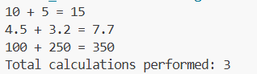

2. Develop a Restaurant Billing Application where overloaded methods calculate bills for dine-in, takeaway, and delivery orders, while static variables track total order.
package Assignment3;

public class BillingApp {

static int totalOrdersCount = 0;
static double totalRevenue = 0.0;
double taxRate = 5.0;

//Track total orders
private void trackOrder(double billAmount) {
totalOrdersCount++;
totalRevenue += billAmount;
}

// 1. Dine-In
public double calculateBill(double foodCost) {
double tax = foodCost * (taxRate / 100);
double total = foodCost + tax;

trackOrder(total);
return total;
}

// 2. Takeaway
public double calculateBill(double foodCost, double packagingFee) {
double tax = foodCost * (taxRate / 100);
double total = foodCost + tax + packagingFee;

trackOrder(total);
return total;
}

// 3. Delivery
public double calculateBill(double foodCost, double packagingFee, double deliveryFee) {
taxRate = 18.0;
double tax = foodCost * (taxRate / 100);
double total = foodCost + tax + packagingFee + deliveryFee;

trackOrder(total);
return total;
}

public static void main(String[] args) {
BillingApp app = new BillingApp();

System.out.println("--- Processing Restaurant Orders ---\n");

// Order 1: Dine-in (Rs.500 food)
double dineInBill = app.calculateBill(500.00);
System.out.printf("Dine-in Order Total: Rs.%.2f%n", dineInBill);

// Order 2: Takeaway (Rs.399.00 food, Rs.4.50 packaging fee)
double takeawayBill = app.calculateBill(399.00, 4.50);
System.out.printf("Takeaway Order Total: Rs.%.2f%n", takeawayBill);

// Order 3: Delivery (Rs.399 food, Rs.4.50 packaging fee, Rs.43.5 delivery fee)
double deliveryBill = app.calculateBill(399.00, 4.50, 70.85);
System.out.printf("Delivery Order Total: Rs.%.2f%n", deliveryBill);

System.out.println("\n=====================================");
System.out.println("--- Daily Summary Dashboard ---");
System.out.println("Total Orders Processed: " + totalOrdersCount);
System.out.printf("Total Revenue Generated: Rs.%.2f%n", totalRevenue);
}

}

Output
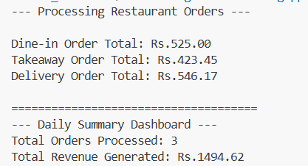

Conclusion: We have successfully implemented method overloading and used static variables and methods in application-specific Java programs.

